**Лабораторная работа 9.**

**Понятие об игровых моделях.**

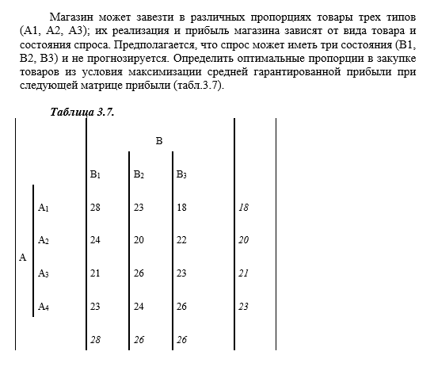

Седловая точка отсутствует, а значит решение необходимо искать в смешанных стратегиях:

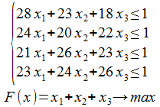

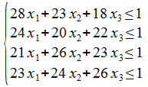

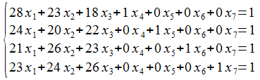

|  |  |  |  |  |  |  |  |  |
| --- | --- | --- | --- | --- | --- | --- | --- | --- |
|  | B | X1 | X2 | X3 | X4 | X5 | X6 | X7 |
| X4 | 1 | 28 | 23 | 18 | 1 | 0 | 0 | 0 |
| X5 | 1 | 24 | 20 | 22 | 0 | 1 | 0 | 0 |
| X6 | 1 | 21 | 26 | 23 | 0 | 0 | 1 | 0 |
| X7 | 1 | 23 | 24 | 26 | 0 | 0 | 0 | 1 |
| F() | 0 | -1 | -1 | -1 | 0 | 0 | 0 | 0 |

|  |  |  |  |  |  |  |  |  |
| --- | --- | --- | --- | --- | --- | --- | --- | --- |
| Базис | B | x1 | x2 | x3 | x4 | x5 | x6 | x7 |
| x4 | 1 | 28 | 23 | 18 | 1 | 0 | 0 | 0 |
| x5 | 1 | 24 | 20 | 22 | 0 | 1 | 0 | 0 |
| x6 | 1 | 21 | 26 | 23 | 0 | 0 | 1 | 0 |
| x7 | 1 | 23 | 24 | 26 | 0 | 0 | 0 | 1 |
| F(X1) | 0 | -1 | -1 | -1 | 0 | 0 | 0 | 0 |

|  |  |  |  |  |  |  |  |  |
| --- | --- | --- | --- | --- | --- | --- | --- | --- |
| Базис | B | x1 | x2 | x3 | x4 | x5 | x6 | x7 |
| x4 | 4/13 | 12(1/13) | 6(5/13) | 0 | 1 | 0 | 0 | -9/13 |
| x5 | 2/13 | 4(7/13) | -4/13 | 0 | 0 | 1 | 0 | -11/13 |
| x6 | 3/26 | 17/26 | 4(10/13) | 0 | 0 | 0 | 1 | -23/26 |
| x3 | 1/26 | 23/26 | 12/13 | 1 | 0 | 0 | 0 | 1/26 |
| F(X2) | 1/26 | -3/26 | -1/13 | 0 | 0 | 0 | 0 | 1/26 |

|  |  |  |  |  |  |  |  |  |
| --- | --- | --- | --- | --- | --- | --- | --- | --- |
| Базис | B | x1 | x2 | x3 | x4 | x5 | x6 | x7 |
| x1 | 4/157 | 1 | 83/157 | 0 | 13/157 | 0 | 0 | -9/157 |
| x5 | 6/157 | 0 | -2(111/157) | 0 | -59/157 | 1 | 0 | -92/157 |
| x6 | 31/314 | 0 | 4(133/314) | 0 | -17/314 | 0 | 1 | -133/157 |
| x3 | 5/314 | 0 | 143/314 | 1 | -23/314 | 0 | 0 | 14/157 |
| F(X3) | 13/314 | 0 | -5/314 | 0 | 3/314 | 0 | 0 | 5/157 |

|  |  |  |  |  |  |  |  |  |
| --- | --- | --- | --- | --- | --- | --- | --- | --- |
| Базис | B | x1 | x2 | x3 | x4 | x5 | x6 | x7 |
| x1 | 19/1389 | 1 | 0 | 0 | 124/1389 | 0 | -166/1389 | 61/1389 |
| x5 | 137/1389 | 0 | 0 | 0 | -568/1389 | 1 | 850/1389 | -1534/1389 |
| x2 | 31/1389 | 0 | 1 | 0 | -17/1389 | 0 | 314/1389 | -266/1389 |
| x3 | 8/1389 | 0 | 0 | 1 | -94/1389 | 0 | -143/1389 | 245/1389 |
| F(X4) | 58/1389 | 0 | 0 | 0 | 13/1389 | 0 | 5/1389 | 40/1389 |

Оптимальный план:

x1 = 19/1389

x2 = 31/1389

x3 = 8/1389

F(X) = 1*19/1389 + 1*31/1389 + 1*8/1389 = 58/1389

y1 = 13/1389

y2 = 0

y3 = 5/1389

y4 = 40/1389

Z(Y) = 1*13/1389+1*0+1*5/1389+1*40/1389 = 58/1389